**Course Title: Digital Logic and System Design**

**Course Code: CSE 210**

**Credit Hour: 1.5**

**Experiment No. 7**

**Experiment Name:**

1. Test and verify the truth table of Clocked D flip-flop (IC#7474)
2. Implement a clocked D flip-flop.
3. Test and verify the truth table of Clocked JK flip-flop (IC#7476).
4. Implement a clocked JK flip-flop.

**Tasks:**

Difference between latch and flip-flop:

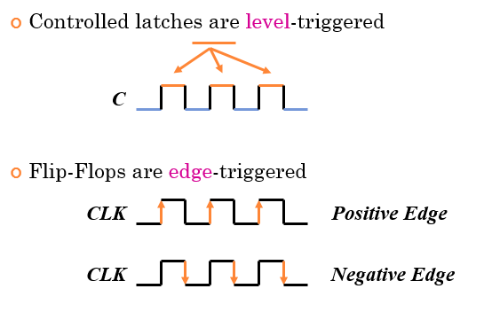

**Implementing Clocked D Flip-flop:**

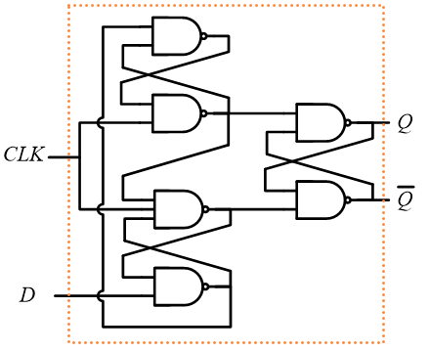

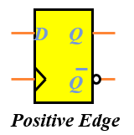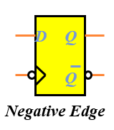

**Implementing clocked JK flip flop:**

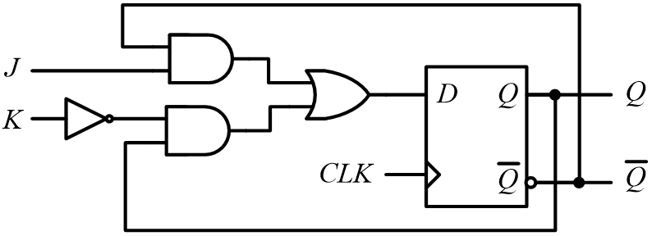

**Report:**

1) Problem Statement

2) Instruments (used in this experiment)

3) IC diagram : #7474 , #7476 (Collect it from net)

4) Truth Table (D flip-flop, JK flip-flop)

5) Logic diagram (4 circuit screenshots from your CIRCUITMAKER projects)

6) Discussion